**Dynamics 365**

**Technology Specialist Environment**

**Hands-On Lab**

Lab 3.0 – Analytics & Reporting

Authored by:

**Scott Sewell**

Principal Program Manager

Version 2.0

Contents

Section One: Adding the PowerBI Assets to your Demo Environment 3

Pre-Requisites to installation 3

Create Local Copies of the Report and Source Data files 4

Create a OneDrive ‘Shared Library’ 5

Connect the PowerBI file’s Data Source to your Excel file 7

Publish the file to PowerBI 8

Section Two: Adding the Power BI report to Dynamics 11

Section Three: Adding a PowerBI report to the account form (Advanced) 13

Update the Sample data with the account names and GUIDs from your organization. 13

Publish the drill-down report to Dynamics 14

Create a Report Placeholder on your form 17

Finally view the contextually filtered report in Dynamics 19

# Section One: Adding the Power BI Assets to your Demo Environment

## Pre-Requisites to installation

1. POWER BI Pro licenses assigned to your demo users.
2. In your environment, ensure that “Power BI Visual embedding” is enabled.   
   [In the “Settings > Administration > System Settings > Reporting” tab]
3. Install the version of POWER BI **desktop** from the windows store: <https://aka.ms/pbidesktop>  
   (If you have installed it as a download from the Power BI page in the past, uninstall that version and use the one from the store. – The version from the store will remain updated automatically as new releases are available.)
4. Ensure that you are logged in to Power BI desktop with your TS account.  
   A screenshot of a social media post

   Description automatically generated

## Create Local Copies of the Report and Source Data files

1. Download the example files from the source: <https://github.com/mscottsewell/ContosoBI> (From the “Code” menu choose “Download Zip”  
   Graphical user interface, text

   Description automatically generated
2. Once Downloaded - right click on the file, select ‘Properties’ and then check the ‘unblock’ option and ‘apply’ that change.  
   Graphical user interface, application

   Description automatically generated
3. Right click on the zip file and “extract” it to a temporary folder on your pc. – We’ll make a few changes before publishing it to your instance.
4. You should see these files in the “\ContosoBI-master\Contoso - Sales - Current Release” folder:  
   Text

   Description automatically generated

## Create a OneDrive ‘Shared Library’

1. Open OneDrive (logged in with your demo admin credentials) – and create a ‘Shared Library’Graphical user interface, text

   Description automatically generated
2. Add your admin, plus any demo user in your environment as a member of this group.
3. Copy the Excel file into that directory. (We’ll copy the PBIX files later)
4. Open the file from One Drive “In App” – (It’s important to open the file from the OneDrive and not from the copy on your desktop.)  
   Graphical user interface, text, application, email

   Description automatically generated
5. With the file open in Excel, click on “File” then “Info” and then “Copy Path”Graphical user interface, website

   Description automatically generated

You’ll need this URL in a moment – so just paste it into some where handy such as notepad or in this document and we’ll use it to update our Power BI source.

It will look something like:

https://d365demots00000.sharepoint.com/sites/ContosoAnalytics/Shared%20Documents/Contoso%20-%20Dynamics%20365%20Sales%20Source%20Data.xlsx***?web=1***

We’ll need all ***except*** that last **“?web=1”**

https://d365demots00000.sharepoint.com/sites/ContosoAnalytics/Shared%20Documents/Contoso%20-%20Dynamics%20365%20Sales%20Source%20Data.xlsx

## Connect the Power BI file’s Data Source to your Excel file

1. From your desktop, open the **Contoso - Dynamics 365 Sales.pbix** file in Power BI – and under the ‘Transform Data’ button, open **Data Source Settings.** A screenshot of a computer screen

   Description automatically generated
2. Update Power BI with the new name and location of the Excel file.  
   (The Excel file must be closed before you can select it as a data source in Power BI.)A screenshot of a cell phone

   Description automatically generated
3. After changing to a new source file, it will prompt you to “Apply changes” to refresh the data in the reports. After this, just click ‘Refresh’ in the ribbon to update Power BI with the updated data in the excel file. (Ensure that the Excel file isn’t open in Excel whenever you ‘refresh’ – the file lock on the local file will prevent Excel and Power BI from playing nicely with each other.)  
   A screenshot of a social media post

   Description automatically generated  
   (Whenever you’ve updated the Excel file, just click [F9] to refresh the Excel formulas, then close the file and then in Power BI click the ‘Refresh’ button to see the changes in Excel updated into Power BI.)

## Publish the file to Power BI

1. Now we’ll publish the Report to your TS Power BI instance. (Ensure you’re logged in to Power BI with your TS account – or Dynamics 365 CE admin account.)  
     
   Save the file and then Click “Publish”  
   A screenshot of a computer screen

   Description automatically generated  
     
   Save this to your “Contoso Analytics” workspace. (Saving to other workgroups is also supported, but for purposes of this set of instructions, we’ll stick with ‘Contoso Analytics’ to reduce confusion.)  
   Graphical user interface, application, table

   Description automatically generated
2. Open the “Contoso Analytics” workspace on PowerBi.com, you should have a copy of the report. – (Be sure you’re logged into Power BI using the same credentials you used to publish the report.)  
   On the dataset (orange icon) – click the three dots to access the settings menu.  
   Graphical user interface, application

   Description automatically generated
3. Set the Credentials to OAuth2, Sign In with the tenant admin credentials and then enable the Scheduled Refresh to refresh daily or weekly.  
   Graphical user interface, application

   Description automatically generated
4. You can now explore the report inside Power BI.  
   Graphical user interface

   Description automatically generated

# Section Two: Adding the Power BI report to Dynamics

1. Open the PowerApp Maker Portal <https://make.powerapps.com/> (be sure your environment is selected) and go to the ‘Solutions’ tab and create a new ‘Contoso Analytics’ Solution  
   Graphical user interface, text, application, email

   Description automatically generated
2. Open this new solution and add a New, Dashboard of type “Power BI Embedded.”  
   Graphical user interface, application

   Description automatically generated
3. Give the new dashboard a display name, then select the Power BI workspace and Report we created earlier, then Save and Publish this solution.  
   Graphical user interface, text, application

   Description automatically generated
4. Next Add and “Existing” App to the solution. Graphical user interface, application, Teams

   Description automatically generated  
     
   We’ll add the dashboard to this app – but you can repeat the process and add it to any app.  
   Graphical user interface, application

   Description automatically generated
5. Open the app in the editor and add the Contoso Analytics Dashboard.  
   Graphical user interface, application

   Description automatically generated

# Section Three: Adding a Power BI report to the account form (Advanced)

A contextual report on an entity form gives the user a powerful tool to show a rollup and metrics around the interactions with a specific account, as an example. A report can be added to an entity form and that report is automatically filtered to the current record.

The “*Contoso - Dynamics 365 Sales - Account Drill-Down.pbix*” report is already configured to use the same dataset published with the main report. There are only a few steps needed to update and publish it into your environment.

## Update the Sample data with the account names and GUIDs from your organization.

Update the account tab in the Excel file to include the Names & GUIDs of your accounts.

1. Export the list of your accounts as a static list.  
   A screenshot of a computer

   Description automatically generated
2. Open it in Excel and ‘Unhide’ Columns A, B, and C (They’re hidden by default in an export.)  
   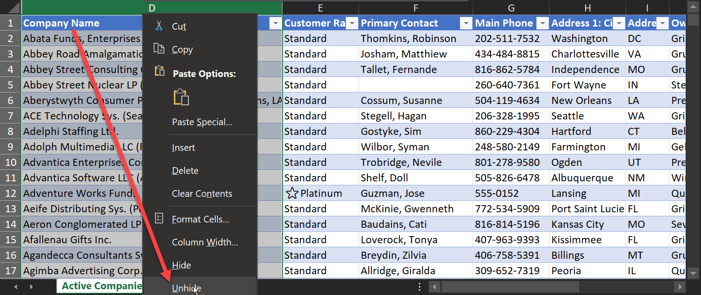  
   (Column “A” should be the Account ID)
3. Add the AccountIDs and the Names of your accounts (and the addresses, etc. if desired) to the corresponding columns on the ‘Account’ Tab of the Data source Excel File. (This step is necessary since the embedded report will be filtered based on the AccountId of the current account record from your environment.  
     
   A screenshot of a computer screen

   Description automatically generated  
     
   Hit refresh (F9) to update the excel file, then Save and close the Power BI Source Data Excel file.

## Publish the drill-down report to Dynamics

1. Refresh the Dataset to ensure the updated date is in the Power BI service.  
   Graphical user interface, text, application

   Description automatically generated
2. Open the Drilldown report (**Contoso - Dynamics 365 Sales - Account Drill-Down.pbix**)   
   If this is the first time you’re uploading a new copy of this report, you should get an error message indicating it can’t find the dataset.  
   A screenshot of a cell phone

   Description automatically generated

Just click “Edit” and repoint the data source to the primary report’s dataset in the Power BI service.  
  
Once the report opens, it should point to the correct dataset. – you can check it at the bottom of the report window.

If the ‘drill-down’ report isn’t pointing to the correct dataset, click “Data source setting” (under the “Transform data” menu) to re-point to the correct dataset.

1. Publish the drill-down report to the same workspace as the primary report.

## Create a Report Placeholder on your form

1. In Dynamics Configuration, add a new, blank tab to the Account form(s) you are using in your demo environment.
   1. In the admin area (make.powerapps.com) navigate to the forms on the Account entity  
      A screenshot of a cell phone

      Description automatically generated
   2. Create a report place holder.   
      Add a new 1-Column Tab to the form. Change the name to “tab_Analytics” and add a user-friendly label such as “Account Analytics” – then Save and Publish the change.  
      A screenshot of a cell phone

      Description automatically generated
2. Use the XRM Toolbox (<https://www.xrmtoolbox.com/>) utility ”Power BI Embedder” to add the report to the account form .
   1. Connect XRMToolBox to the environment
   2. Search for and open the “Power BI Embedder” plugin.   
      A screenshot of a cell phone

      Description automatically generated  
      (More information about this utility is located here: <https://dynamicsninja.blog/2019/12/05/power-bi-embedder-for-xrmtoolbox/>)
   3. Select the Account entity in the first drop-down.
   4. In the next three dropdowns, select the **Form**, **Tab**, and **Section** from the earlier steps where you configured the report placeholder.
   5. Change the “Rowspan” value to 15
   6. Set the filter checkmark to yes.
   7. In the filter area on the lower right-hand corner, use “**Accounts**” as the table and “**AccountID**” as the PBI Column. (Please be careful to match this exactly, these values are CaSe SeNsiTivE!)   
      Select “accountid” from the CDS Field dropdown.
   8. For the Group ID and the Report ID, you’ll get those from the ‘drill-down’ report in power bi  
      A screenshot of a computer

      Description automatically generated
3. Save and publish the report from within the Power BI Utility.  
   A screenshot of a social media post

   Description automatically generated

## Finally view the contextually filtered report in Dynamics

1. Open one of your account records in Dynamics and switch to the new Analytics tab.  
   The embedded report should be filtered to the record you have open. (of course, the count of opportunities, calls, cases and everything else is sourced from the Excel file, so don’t be surprised by that.)  
   Graphical user interface, application

   Description automatically generated